Mike L. Perry
Associate Director, Electrochemical Systems

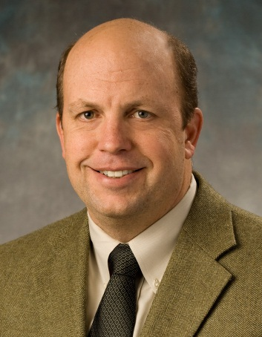
BIOGRAPHICAL PROFILE
Mike Perry is the leader of Electrochemical Systems projects at United Technologies Research Center (UTRC). In this role, Perry leads exploratory investigations of a variety of electrochemical systems that can potentially result in new business opportunities for United Technologies Corporation (UTC). His primary focus is identifying key technical barriers to commercialization of electrochemical system and then formulating novel concepts to overcome those barriers. To this end, Perry forms research teams and procures sufficient funding (both internal to UTC and/or external funding) as appropriate to develop and demonstrate potential advanced concepts. If successful, each new technology is transferred to the appropriate UTC business unit to enable the development of advanced and differentiated future products. With the advanced flow battery project, Perry also pioneered a new business model for UTRC: licensing technology intellectual property to a new start-up company, Vionx Energy, created specifically for commercialization of the breakthrough RFB technology developed by UTRC.

Perry joined UTC in 1999 to work on Polymer Electrolyte Fuel Cells (PEFC). At UTC Power, he led teams conducting fundamental research on PEFCs focused on improving the cost, reliability, durability, and freeze tolerance of stacks and complete systems. In 2008, Perry transferred from UTC Power to UTRC, where he initiated a project on advanced flow batteries. Earlier in his career, Perry served for nine years in the U.S. Navy as a naval aviator flying EA-6B Prowler aircraft from various aircraft carriers. He is a veteran of the First Gulf War in Iraq in1991.

Perry holds more than 60 patents/filed applications related to fuel cells and flow batteries and is a co-author of four different book chapters on fuel-cell durability and diagnostics. He is active member of the Electrochemical Society, and he is also the recipient of such prestigious industry honors as the R&D 100 Award and the Electrochemical Society’s New Electrochemical Technology Award. Perry has also been the prime P.I. on three separate ARPA-e projects. He earned a B.S. degree in chemical engineering from the University of California, Santa Barbara and a M.S. in chemical engineering from the University of California, Berkeley where his mentors were Profs. Elton J. Cairns and John Newman.

