Second Year Thematic Experiential Programs (STEPs) Application
The Second-Year Thematic Experiential Programs (STEPs) are designed specifically for students in their second year who are looking for new and exciting ways to take the next steps towards exploring their passions and career interests during their time at Northeastern. Participants will challenge themselves to grow holistically by refining their skills and interests. Each STEP will help students to further develop themselves personally and professionally while preparing for success in and after college, all while exploring what our great city of Boston has to offer. Students will have access to faculty and staff with similar interests to enhance their second year living on campus, and will participate in targeted programs and events based on the theme of their chosen STEP.
Applications must be completed by Noon on Thursday, February 8, 2018.
NOTE: Housing and Residential Life reserves the right to reassign your housing if you fail to actively and positively participate in the STEP program.
Please contact Rosemary Colucci, Assistant Director of Residential Life, with questions related to the Second-Year Thematic Experiential Program at r.colucci@northeastern.edu or 617-373-2042.
Second-Year Thematic Experiential Program Community Descriptions
Civic Engagement
The Civic Engagement STEP will provide second year students with opportunities to explore their passion for helping others while learning more about themselves through service and engagement opportunities. In addition, participants in the Civic Engagement STEP may partner with our Community Service Office to broaden their experiences with volunteer events that occur around the greater Boston area. Participants in this STEP will be encouraged to be creative and develop their own service/volunteer projects. The Residence Hall location for the Civic Engagement STEP is to be determined.
Healthy Living
The Healthy Living STEP will provide second-year students an environment to learn, grow and be healthy in all aspects of their lives. Participants in the Healthy Living STEP will be offered opportunities to learn about the seven dimensions of wellness (social, emotional, spiritual, environmental, occupational, intellectual, and physical) and how each intersects and affects their lives and experiences at Northeastern. Participants will collaborate together to define goals for the STEP and establish ways to keep the community engaged throughout the academic year. The Residence Hall location for the Healthy Living STEP is a standard double apartment in Willis Hall. The apartment rates are listed below.
Leadership
The Leadership STEP will provide second-year students opportunities to strengthen their leadership skills through a variety of exciting and engaging experiences. These opportunities may include: service projects, group discussions, and programs and events crated by participants, faculty, and staff. By joining in this STEP, participants will feel more prepared to be better leaders on campus and beyond Northeastern. The Residence Hall location for the Leadership STEP is a standard or economy double apartment in Burstein Hall. The apartment rates are listed below.

Second-Year Thematic Experiential Program Preference
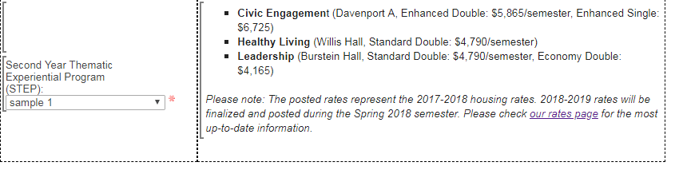
- Civic Engagement (Davenport A, Enhanced Double: $5,865/semester, Enhanced Single: $6,725)
- Healthy Living (Willis Hall, Standard Double: $4,790/semester)
- Leadership (Burstein Hall, Standard Double: $4,790/semester, Economy Double: $4,165)
Please note: The posted rates represent the 2017-2018 housing rates. 2018-2019 rates will be finalized and posted during the Spring 2018 semester. Please check our rates page for the most up-to-date information.

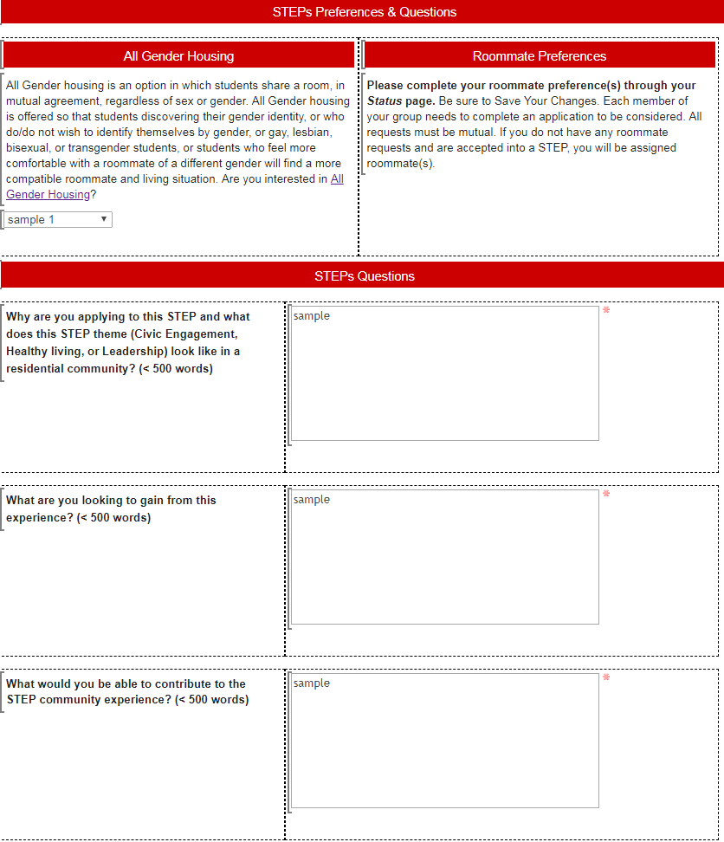

Agreement
Participation Expectations:
As a member of a STEP, your active participation is essential creating a strong community and program. The following expectations as a participant are:
- By completing the application, you are agreeing to actively participate within the community by regularly attending programs, community events, and community meetings.
- Attend a community meeting at the beginning of each semester to establish community expectations.
- Provide assistance during Welcome Week for First Year Living Learning Communities (Healthy Living, Leadership, Community Service).
  - This may include greeting students during move-in, answering questions about campus, or volunteering for Residential Life Welcome Week Programming.
- Establish on-going events and traditions with the STEP.
- Actively participate in forming an inclusive community.
- Nominate a STEPs Hall Council representative.
* If participants do not meet or fulfill involvement expectations, they may be removed from the community.
Application Details:
- Everyone in the apartment/suite that you’d like to live with must also complete the STEP application.
- Students who apply alone will be assigned to live with other students who applied for the STEP program.
- Students departing campus for Spring 2019 for co-op or study abroad are still eligible to participate.
- By completing the application, you will not participate in Room Selection process. You will be assigned to an apartment/suite based on the STEP you have applied to with the roommates you have selected to live with. Assignments will be selected and sent to you via email during the week of February 12, 2018.
- Students who are offered placement in a STEP and accept: please note that your placement is final.

Confirmation page
Hello [[Profile..First_Name]],
Thank you for submitting a STEP application. We will contact you with an update on your status during the week of February 12th. In the meantime, please plan on taking part in Housing Selection and reviewing all of the options in the event your application is not accepted.
Should you have questions, please contact Rose Colucci at r.colucci@northeastern.edu or 617-373-2042
Sincerely,
Residential Life

Confirmation email
None.

