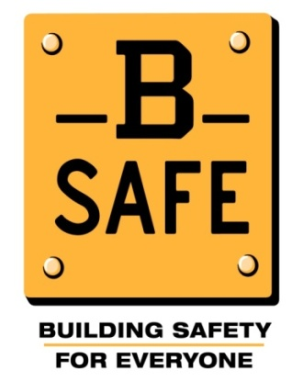
Safety Recognition and Communication Program

This is a safety recognition and communication program that will reward everyone on-site for working safely. [Owner/GC Name] already conducts weekly safety assessments on this site. These assessments provide an overall safety score for the worksite.
How are safety scores calculated?
- Safety management take note of unsafe conditions as well as safe work practices (called “unsafes” and “safes”).
    - For example: Fall protection, housekeeping, PPE, and environmental concerns such as dust control and noises
- The safety score represents the number of safes out of the total number of observations.

- The score takes into account the potential danger of each situation.
Different trades, different risks:
- Since risks vary across trades, dangerous tasks performed safely get more points.
- For example, a contractor would get more credit for having correct fall protection than for having proper trash storage.

If the site’s monthly safety score is above [threshold%], all workers will be treated to a free lunch from [restaurant name] and be eligible to participate in a free [high value item] raffle.
Feedback:
- Each week, the worksite safety score will be displayed on a poster.
- Individual contractors will also be able to see their individual company’s safety scores.
- If the overall safety score for the site is above [threshold %] at the end of the month, everyone on-site will receive a free lunch and be eligible to participate in a free [high value item] raffle.
Contractor | Safety Score
Contractor A | 80%
Contractor B | 92.7%
Contractor C | 88.2%
Contractor D | 100%
Contractor E | 95.2%
Contractor F | 96.6%
Contractor G | 85.0%
Overall | 91.1%

